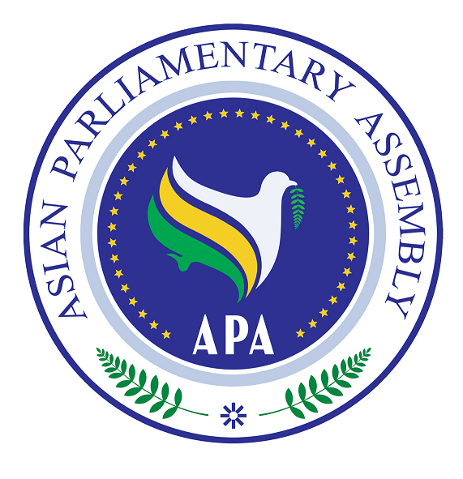
Asian Parliamentary Assembly (APA)
REGISTRATION FORM
APA Coordinating Meeting on the sideline of the 145th IPU Assembly
Kigali Convention Center
(Tuesday 11 Oct. 2022, 15:00 - 16:30)
Meeting Room – MH1
Kigali- Rwanda

Please fill in one registration form for each participant (in block capitals) and return it to APA Secretariat at the following e-mail address latest by 05 October.
- Delegation of: …………

- Title: Please check Mr. Ms. Dr. other
- First Name:
- Last Name:

- Position in the parliament
……………………………………………………………………………………

- Phone No. | - …………………..……………………………………………..  - Country Code City Code Number
- Cell phone  - Fax No. | - …………………………………………………………………  - ………………………………………………………………..
- Email Address: | - ……………….……………………………………………..

Any Proposal on Emergency Item:

